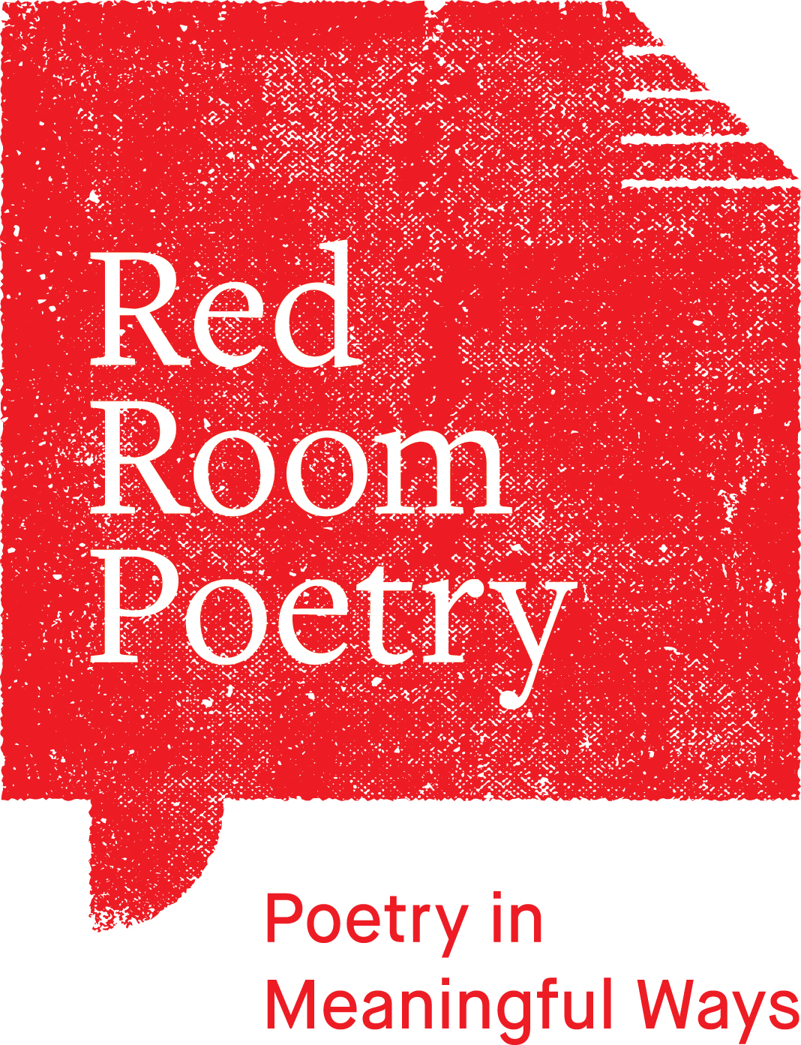

Red Room Poetry

WRITNG WATER CONTRIBUTOR AGREEMENT

Parties to this agreement

[insert name]

and

The Red Room Company Limited
ABN: 35 103 464 446

Private & Confidential

12 September 2020

Dear _____________________

Thank you for the contribution of ​your poem (‘Contribution’) which has been selected for publication within the Writing Water chapbook, the terms of which are as follows:

Principal

Red Room Poetry (“RR”)

Contributor

Services under this agreement will be provided by the Poet ABN [_____________________] (“You”).

Contribution

Red Room Poetry will publish your poem (‘Contribution’) within the Writing Water chapbook

Payment of Fee

In consideration of your reproduction of the Contribution, RR will pay you a one-off fee (“Fee”) as set out in the Schedule, which includes payment for all of the rights you are granting to us under this Agreement.

The Fee is exclusive of GST. If a supply under this agreement is subject to GST, the recipient must pay to the supplier an additional amount equal to the amount of the consideration multiplied by the applicable GST rate. The additional amount is payable at the same time as the consideration for the supply is payable or is to be provided. However, the additional amount need not be paid until the supplier gives the recipient a tax invoice. If the additional amount differs from the amount of GST payable by the supplier, the parties must adjust the additional amount. If a party is entitled to be reimbursed or indemnified under this agreement, the amount to be reimbursed or indemnified does not include any amount for GST for which the party is entitled to an input tax credit.

Nature of relationship

You are engaged as an independent poet, and not as an employee of RR.

Discrimination, bullying and sexual harassment are unacceptable at RR and are unlawful. Agreements with contractors engaging in unlawful activities, discrimination, bullying or harassment will be terminated immediately.

Confidentiality

You must keep all Confidential Information strictly confidential and not disclose it to any person without RR’s prior consent or as required by law.

“Confidential Information” means confidential, non-public or proprietary information, regardless of how the information is stored or delivered, disclosed by RR to You or obtained by You before, on or after the date of this agreement relating to the business, technology or other affairs of RR.

Copyright
The poet retains copyright of the work.
You confirm that you are the sole proprietor of your ‘Contribution’; that it does not infringe any existing copyright; and that to the best of your knowledge it contains no libellous or other unlawful matter.

8 Proofing

RR will provide poets a proof version of the ‘Contribution’ for review. If no response is received from the poet by the required date it will be assumed the proof is correct.

RR will ensure that your “Contribution’ is appropriately credited.

RR may also edit any submitted bios that are longer than 70-words to adhere to the publication page count.

If you agree to the terms of this agreement, please digitally sign, date and upload the agreement with your invoice fee of $60 to the digital portal by 21 September 2020.

Yours faithfully
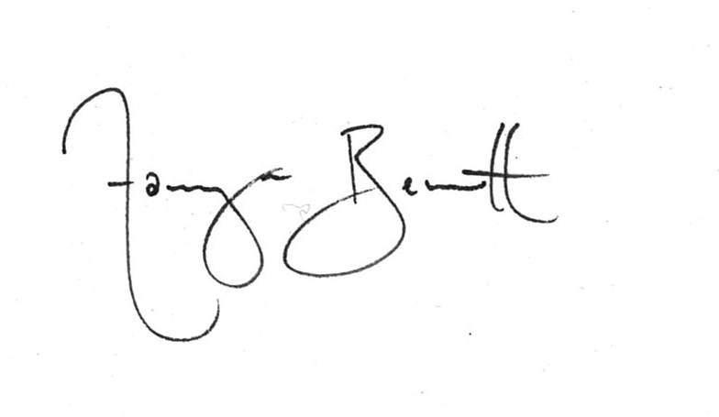
Tamryn Bennett
Artistic Director

I accept the terms and conditions set out in this letter.

……………………………………. …………………………………….
Signature of/on behalf of You Date

SCHEDULE OF SERVICES

Poet or Other Party (“You”):

Project:

Writing Water: Rain, River, Reef

Red Room Poetry’s Writing Water project is commissioning celebrated poets and inviting public submissions that look below the surface and reimagine our essential relationships with water. From the slow-moving waters of TarraWarra in Victoria to the extinction of corals and conversations with wetlands in Western Australia, poems are provocations to honour, remember and interrogate our responsibilities with water in a time of environmental change.

Guest edited by Eunice Andrada, the Writing Water chapbook will feature a selection of 20 public contributions along with commissioned poems by Eunice Andrada, Tony Birch, Luke Davies and Georgina Reid.

Chapbooks will be freely distributed on ferries for the poetic delight of the public with limited edition copies available for sale via the Red Room Poetry website.

Deliverable ‘Works’ and Timeline:
- Completed: submission and acceptance of original poem
- By Monday 21 September: Signed agreement, invoice, poet biography and photo to have been uploaded via Red Room Poetry website
- November: scheduled public release Writing Water chapbook on ferries and digital promotion

Fee:
Poem publication: $60

Total: $60

RR will pay the Fee upon receiving this signed agreement and a tax invoice from you.

As an independent contractor you will be solely responsible for the payment or withholding of any tax arising in respect of the payment of, or receipt of, the Fee and must remit all such tax payments to the ATO or state revenue office as required.

Thanks again for being a part of Writing Water.

